# [https://avatars2.githubusercontent.com/u/4156894?v=3&s=100](http://www.calstatela.edu/centers/hipic) CIS5560 Term Project Tutorial

#### Authors: Rick Gonzalez

#### Instructor: [Jongwook Woo](https://www.linkedin.com/in/jongwook-woo-7081a85)

#### Date: 03/29/2023

**Lab Tutorial**

Rick Gonzalez([rgonza91@calstatela.edu](mailto:rgonza91@calstatela.edu))

03/29/2023

**Tesla Model 3 Sales Analysis using Clustering in SAC**

**Objectives**

In this hands-on lab, you will learn how to: segment – Tesla Model 3 sales by dealership, based on various attributes, such as City, Zip code, Salesforce and car model to help with strategic sales operations.

* Get data manually using Excel.
* Apply Smart Grouping cluster analysis.
* Create data visualizations.
* Analyze and interpret output from models.

**Platform Spec**

* SAP Analytics Cloud
* Microsoft Excel
* CPU Speed: 3.5 GHz
* # of CPU cores: 4 to 6 Cores
* # of nodes: 1
* Total Memory Size: 8 GB

Step 1: Get data manually using Microsoft Excel

This step is to get raw data manually and import it on to SAP to create Clustering.

1. Open a web browser and go to SAP Analytics Cloud (SAC): https://highereducation. us10.sapanalytics. cloud/Sign into your data account
2. Log in SAP Analytics Cloud (SAP)
3. Upload the file “Tesla.csv” to SAP Analytics Cloud > save it to your path Cal State LA Bus5100 data > Stores.csv.
4. Create a Dataset.

a. From the left menu bar, select the menu Data Set.

b. Select the file from your computer: **Create New** (From a CSV or Excel file) > **Select Source File**

C. Select *Tesla.csv.*

*(1)* Use the first row as column headers should be selected as default

d. Hit import. 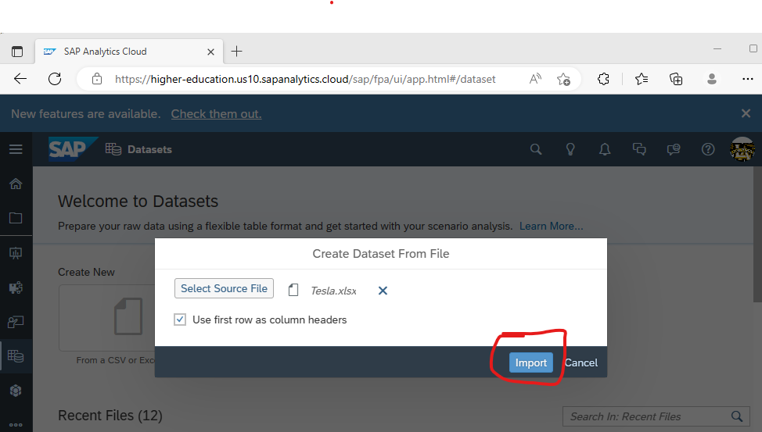

e. Choose your folder in SAP for the location of the data file you downloaded. Save it as **Tesla.**

You will then see the data in SAP.

Step 2. Visualize the Store Data

1. In The main menu, Select Create Story.

2. Select **Responsive.**

**a.** If you see the following select “Classic Design Experience” click **Create.**

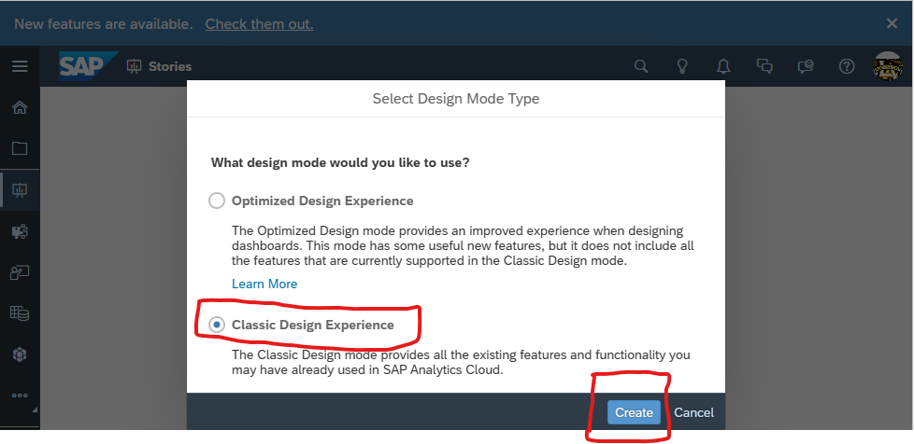

b. In Story, select **Data**. Then, look for **Tesla** from your files. Choose **Tesla**.

Select change the Story view from Data view at the top left corner.

1. Insert **Chart.**
2. Select Bubble Chart from the Builder panel charts.
3. Configure inserted charts as follows:
4. Add sales to X - Axis
5. Number of dealerships to Y – Axis
6. A picture containing text, indoor, electronics, display

   Description automatically generatedAdd Locations to Dimensions
7. Add tooltip Measure:

1. A bubble chart will show, showing the measures you selected.
2. Save it to your folder is SAP as “Tesla”.

3. Creating the Cluster Analysis



1. Select Chart to see Builder Enable and Toggle on Smart Grouping

2. Change the Number of Groups to 3, (3 is k in the k-means algorithm).

3. Change the Group Label to “Cluster” to be consistent with understanding of cluster analysis. When typing in cluster it will automatically change to “Cluster [#]”

4. Select Include Tooltip Measures in grouping so that all measures selected are reflected in the cluster analysis.

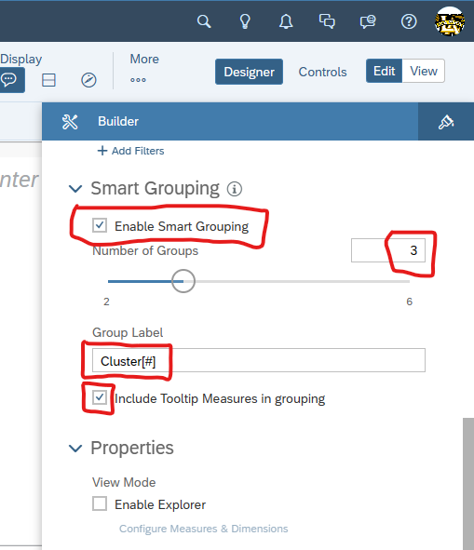

5. Three distinct clusters appear in your chart.

a. The clusters in the default monochromatic color scheme tend to blend, therefore please change the Color pallet.

b. Filter is an option by clicking on the cluster you want to analyze.

c. Add “Tesla Model 3 US Sales 2022” as the title of the clustered bubble chart.

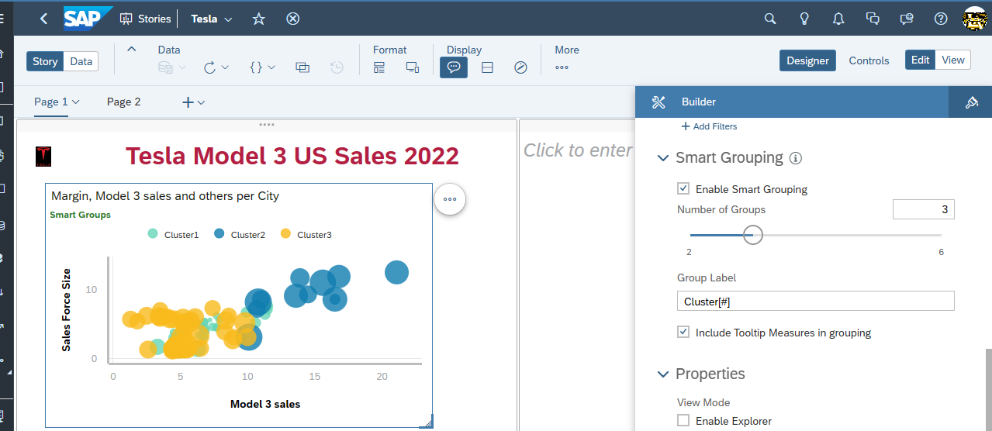

1. You may insert Tesla Logo in front of the title.

**4. Visualization and Interpretation**

1. Change color of clusters.

a. Select **Designer > Drop Down > Orange color.**

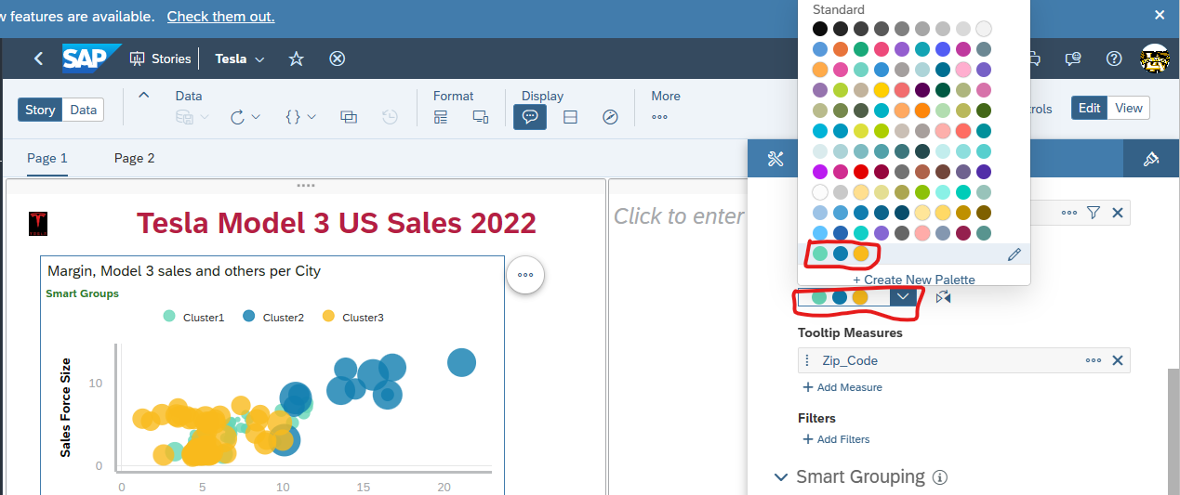

2. Merging data sets.

a. Filter to Cluster 1 by clicking “Cluster 1” on the legend of the bubble chart you created. Refer to depiction below.

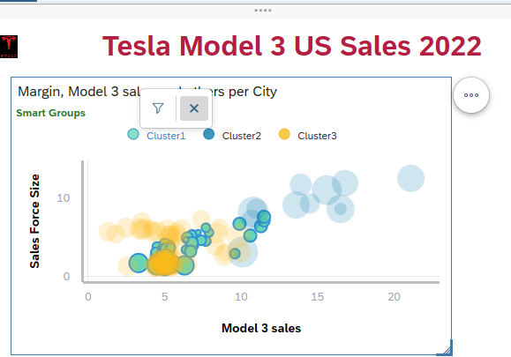

Select Export from the chart below: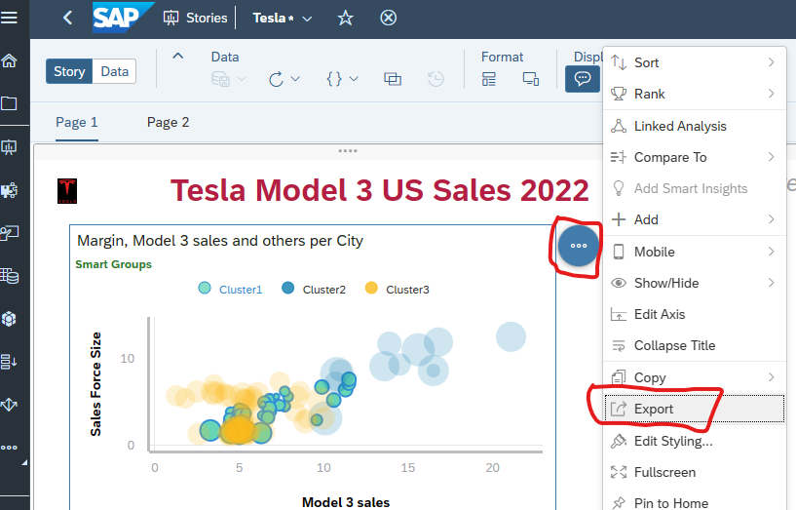

3) Name the .csv file “Cluster 1”. Select OK and see Cluster 1.csv file is downloaded to your computer. That is, the data from cluster 1 will be downloaded to your computer.Graphical user interface, application

(4) Click “Remove” icon to remove the filter as following screenshot. It is important step to create the correct clusters 2 and 3.

c. Repeat these steps for clusters 2 and 3 and name the files “Cluster 2” and “Cluster 3” respectively. You should have three downloaded .csv files. d. Now you will prepare the cluster data for integration with the Stores data model in SAC. (1) The first step is to clean up the header so that it is only one row. Open the Cluster 1.csv file. (i) Move content of cells B1:D1 to cells B2:D2, that is, move them to the next row. See Figures 6 and 7.

Then, delete row 1.

(2) **Next** add a column called “Cluster”

Add the cluster number to all the rows of data.

(3) Save the .csv file.

(4) You can see the results of your clean up in above figures.

e. Repeat these steps for clusters 2 and 3. f. To merge the cluster data with the Stores data, do the following. (1) Go to Data view. (2) On the dropdown menu next to Stores, select + **Add New** Data.

(3) Select **Data uploaded from a file**.

(4) Select Source Cluster 1.csv.

(i) Use first row as header should be selected. (ii) Import. (iii)

**NOTE:** You must choose Grid View mode

on the Save dropdown, select Open with Basic Data Preparation. This will allow you to append the files for clusters 2 and 3.

Select **Reimport Data** from the Data ribbon.

You will see the following. Select OK.

**Select Cluster** **2**.csv by selecting “Import File” in the pop-up window. (10) With the default option as you saw for Cluster 1.csv, select Import.

Select **Append.**

3. To visualize the Sales and Clusters data, go to the Story view.

a. Add a new page with either a Canvas or a Responsive page. Both has Chart menu. b. Add a chart. c. Add a calculated measure for Count of Stores as shown below. Hint: +Add Measures > + Create Calculated ... (1) Select OK

Repeat the append for Cluster 3.csv. S

elect Save.

At page 1, you can see 3 clusters that shows the detail of each store at a cluster. And, at page 2, you can see how many stores at each cluster. to get the credit. Or submit their screenshots in a single pdf – or word - file if you did not get the credit at the lab class.

Cluster #2, color blue depicted in pie chart above indicate sales of Tesla Model 3 by City, zip code and number of vehicles sold in the first quarter of 2023, cluster 2 accounts for approximately 34% sales in the United States, I pinpoint to Miami for visual aid reference of cluster 2.

Cluster #1, color aqua depicted in pie chart above indicate sales of Tesla Model 3 by City, zip code and number of vehicles sold in the first quarter of 2023, cluster 1 accounts for approximately 20% sales in the United States, I pinpoint Cincinnati for visual aid reference of cluster 1.

Cluster #3, color yellow depicted in pie chart above indicate sales of Tesla Model 3 by City, zip code and number of vehicles sold in the first quarter of 2023, cluster 3 accounts for approximately 46% sales in the United States, I pinpoint Las Vegas for visual aid reference of cluster 3.

References

* 1. [Term Paper.docx](https://1drv.ms/w/s!Au-BZkqgA0hciAk8JT6G9oFcDmCn?e=vEnDlM)
  2. [Number of Tesla locations in the USA in 2023 | ScrapeHero](https://www.scrapehero.com/location-reports/Tesla-USA/#topStatesScrollPoint)
  3. [Compare Vehicles Tesla Model 3 vs. Tesla Model S vs. Tesla Model X vs. (carfigures.com)](https://carfigures.com/widget/compare/us_tesla_model-3-vs-us_tesla_model-s-vs-us_tesla_model-x-vs-us_tesla_model-y)
  4. <https://github.com/Rgonza91/Term-Paper.git>